EARTH FUND PLATFORM IDENTIFICATION FORM (EFPIF)
The GEF Earth Fund Trust Fund
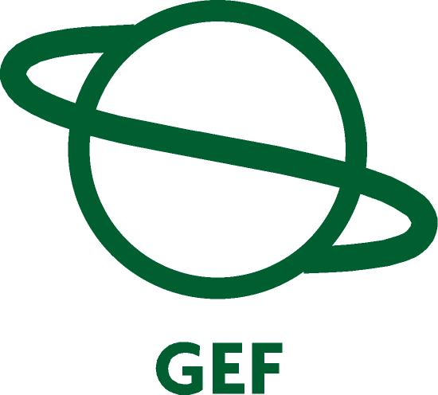

Submission Date to Earth Fund Board: 02/01/2010

part i: pLATFORM IDentification
Indicative Calendar*
Milestones | Expected Dates  mm/dd/yyyy
Council Approval | 03/20/2010
CEO Endorsement | 06/15/2010
Implementation Start | 07/01/2010
Mid-term Evaluation (if planned) | 01/01/2013
Implementation Completion | 06/30/2015
See guidelines for definition of milestones.
GEFSEC Project ID:
Project duration: 60 months
gef agency Project ID:
Country(ies): Latin America and the Caribbean
Platform Title: Public-Private Funding Mechanisms for Watershed Protection

GEF Agency: IDB

Other Executing partner(s): The Nature Conservancy

GEF Focal Area (s):

GEF-4 Strategic program(s): SO1, SO2, SP1, SP3, SP5
Name of parent program: The GEF Earth Fund

- Platform framework
Platform Objective: Consistent with the purpose of the GEF Earth Fund, the objective of this Platform (the Platform) is to deploy public-private funding mechanisms, the Water Funds, and their related institutional structures that will subsequently be operated as sustainable long-term instruments to promote private sector participation in the conservation of freshwater ecosystems and biodiversity of global importance.
To pursue this objective, the Platform will support the establishment of at least five water funds across Latin America and the Caribbean (LAC) that will attract contributions from a variety of sources - large water users, such as water utilities, bottling companies and other industries; taxes; individual donations and international donors – (i) to pay for nature’s water and biodiversity related services and (ii) use those contributions to support conservation projects for further protection of the healthy habitat from which these services derive. Eligible conservation projects for funding include creating and strengthening protected areas, helping neighboring landowners switch to conservation-friendly practices, and supporting other community-driven conservation initiatives.
With the Platform, it is expected that ecosystems and species of global importance will benefit from having larger and better protected territory, local communities will benefit from improved water quality and a healthy watershed, upstream farmers will benefit from improved sustainable farming practices and the economic incentives to continue to provide valuable water services and large water uses will benefit from reduced water treatment costs, delayed infrastructure replacement investments and increased water security.

Project Components | Indicate whether Investment, TA, or STA^{b} | Expected Outcomes  (indicators and target) | Expected Outputs (indicators and target) | Indicative GEF Financingª |  | Indicative Co-Financingª |  | Total ($)  c =a + b
 |  |  |  | ($) a | % | ($) b | % | Total ($)  c =a + b
Water Funds | TA | a) Increased protection of terrestrial and freshwater ecosystems and species of global importance(# of protected areas systems being strengthen and financed and # of hectares of private land in upstream catchment areas managed effectively for freshwater conservation: at least five national protected areas covering at least 800,000 hectares and at least 70,000 hectares of private lands under conservation and/or sustainable farming agreements)  b) Improved water ecosystem services, in particular increased water security and quality for large water users ( Sediment retention benefits derived from the conservation projects outweigh operational recurrent costs in filtration and dredging or capital cost of new infrastructure development; reduction in water treatment, dredging and/or infrastructure costs | a) Water Funds , established and functioning ( # of watersheds with an established and functioning water fund; at least five watershed in five Latin American and Caribbean countries)  b) Increased private and public sector funding to pay for water and biodiversity related services (leveraging achieved. USD 15 Million)  c) Improved stakeholder participation in collaborative processes for biodiversity and watershed protection ( additional number of partners engaged in accountable management of watersheds; at least 15 new partners are engaged in the water funds being supported) | 4,500,000 | 23 | 14,500,000 | 77 | 19,000,00
2. Project Management & Monitoring |  |  |  | 500,000 | 50 | 500,000 | 50 | 1,000,000
Total project costs |  |  |  | 5,000,000 | 25 | 15,000,000 | 75 | 20,000,000
ª List the $ by project components. The percentage is the share of GEF and Co-financing respectively of the total amount for the component.
^{b} TA = Technical Assistance; STA = Scientific & Technical Analysis.
B. Indicative Financing Plan Summary For The Platform ($)
 | Previous Project Preparation | Project | Agency Fee | Total
GEF financing |  | $5,000,000 | $450,000 | $5,450,000
Co-financing |  | $15,000,000 |  | $15,000,000
Total |  | $20,000,000 | $450,000 | $20,450,000

C. Indicative Co-financing for the platform (including project preparation amount) by source and by name (in parenthesis) if available, ($)
Sources of Co-financing | Type of Co-financing | Project
Government Contribution  (Municipalities and Environmental Authorities) | Cash | 5,000,000
GEF Agency(ies)
Bilateral Aid Agency(ies)  USAID and others | Grant | 1,000,000
Multilateral Agency(ies)
Large Water Users  (Private Associations of Colombia, Water Utility Companies, Hydropower Companies, Beverage Companies and other key water users) | Cash | 8,000,000
NGO (TNC and others) | Cash | 1,000,000
Others
Total Co-financing |  | 15,000,000

D. GEF Resources Requested by agency (ies), Focal Area(s) and country(ies)¹
GEF Agency | Focal Area | Country Name/  Global | (in $)
GEF Agency | Focal Area | Country Name/  Global | Project (a) | Agency Fee (b)² | Total c=a+b
Total GEF Resources |  |  | 0 | 2 | 0
¹ No need to provide information for this table if it is a single focal area, single country and single GEF Agency project.
² Relates to the project and any previous project preparation funding that have been provided and for which no Agency fee has been requested from Trustee.

part ii: platform JustiFication

I. Issue Statement and Proposed Solution:
- Development and climate change are causing every natural ecosystem to be put under high stress, freshwater ecosystems—the diverse communities of species found in lakes, rivers, and wetlands—being the most endangered of all. Despite occupying only a tiny percentage of the planet’s surface, on a hectare-to-hectare basis, freshwater ecosystems are richer in species than the more extensive terrestrial and marine ecosystems.
- However, these ecosystems have lost a greater proportion of their species and habitat than ecosystems on land or in the oceans due to increasing threats from dams, water abstraction, overharvesting, pollution, deforestation, and the presence of invasive species. Climate change promises to cause further challenges given anticipated changes in the seasonality and annual patterns of precipitation.
- The increased degradation, hydrological variability and changes in land use have serious consequences in the green infrastructure and associated water-related services that these ecosystems provide. Wetlands store runoff, recharge aquifers, and digest organic waste, while forests shade streams, reduce runoff and halt erosion. Without this green infrastructure, businesses and utilities and other large downstream users would have to incur significant water treatment and dredging costs and large infrastructure replacement investments.
- While evidence suggests that it is more cost effective to protect than mitigate, the costs of watershed management have been almost universally neglected in water pricing. Worse still, these costs have not been valuated against operational costs for water treatment or investment costs for new infrastructure. Recent evidence in the shrinking clean water supplies and perceived water insecurity has made businesses and water utilities look at fresh water as they never have before - a valuable good that is produced, sold and consumed and deserves investment.
- Cities, such as New York, have decided to make large scale investments in ecosystem management to protect water quality, rather than invest in filtration plants. Likewise, the city of Bogota will soon reap the benefits of investing in watershed conservation: experts forecast that after a four-year conservation investment the city will save part of its $4.5 million annual sedimentation removal cost.
- There is an urgent need to replicate experiences such as these and create funding mechanisms to offer downstream users the opportunity to be proactively engaged in collaborative processes for the conservation of upstream catchment areas. Despite the numerous efforts to manage watersheds, few programs address the link with protected areas, which in many cases were originally created to protect water sources, and farmlands in the upper watershed. Indeed, in the case of Colombia 50% of its citizens receive its water from public protected areas but market and institutional failures have caused over the years that these areas do not get the necessary financial funds to be well managed. On the other hand, the provision of vital hydrologic environmental services by upstream private and communal lands is not compensated by downstream users. The current incentives are for farmers to continue with current land practices that negatively affect the level and quality of the valuable hydrological and biodiversity related services that their lands provide. The working hypothesis adopted by this Platform is that it would be more cost efficient to compensate farmers to improve land practices, set aside private areas for conservation and improve management of public protected areas.
- In recognition of this opportunity, The Nature Conservancy (the Conservancy) and local partners have worked for over a decade pioneering financial and institutional mechanisms that protect biodiversity while conserving water sources for human consumption. Water Funds are an innovative way to pay and compensate for nature’s services – in this case supplying clean freshwater and providing biodiversity-related services – and reinvest that money in conservation projects that protect the healthy habitat from which these services derive. The Funds attract contributions from large water users such as water utilities and local industries that build up those Funds’ capital, including endowments. In turn, endowments are invested in a wide range of asset categories (e.g. money market, bonds, stocks) and the financial income from those investments provides long term secure funding for conservation projects such as creating and strengthening protected areas, helping neighboring landowners switch to conservation-friendly practices, pay for conservation easements, and financing other important environmental initiatives for local communities. Species benefit from having larger and better protected territories, and communities benefit from a healthy watershed and large water users through reduced water treatment costs that result from proactively funding watershed protection. See Annex A for a list of Water Funds in operation or under development by the Conservancy.
- One of the Conservancy’s most successful models has been the Quito Water Protection Fund in Ecuador. Called Fondo del Agua (FONAG), this public-private mechanism was established in 2000 and is now a Fund with a capitalization of more than US$6 million that pays for watershed programs and projects around Quito’s water sources. Quito’s 1.5 million inhabitants derive 80% of their water from three national protected areas: Cayambe-Coca, Antisana, and Cotopaxi. The mechanism was created to bring together public and private sector water users to pay for conservation efforts on a voluntary basis. Programs receiving support include adding park guards and control for protected areas, environmental education and outreach, and helping people who live in sensitive areas switch to more ecologically sound livelihoods.
- Based on the experience with the Quito Water Fund, the Conservancy and local stakeholders are replicating and improving the model for public-private watershed conservation in parts of South America, namely in Colombia, Ecuador, and Peru (see Annex A). The Conservancy has adapted the strategy across geographic gradients: from valleys, to mountain forests, dry forests and coastal lagoons. In addition, it is working to engage multiple types of water users from large hydropower companies to the agricultural sector, from large companies to individual farmers.
- This Platform will give evidence of those adjustments through establishment of Water Funds across Latin America and the Caribbean (LAC), with GEF funding directed at support for critical Water Fund start-up costs and largely on the endowments which as noted in the GEF’s Scientific and Technical Advisory Panel (STAP) Guideline Document on Payment for Environmental Services and the Global Environmental Facility (Guideline Document GEF/C.35/ Inf.12, June 2, 2009) offer the greatest return on biodiversity conservation. It is expected that at least five Water Funds will be designed and put in place under this Platform, including investments in the endowment funds of the Bogota and Lima Water Funds and co-financing in the Lima Water Fund’s feasibility studies. At least three other Water Funds will be selected for financing under this Platform (potentially in priority areas in Mexico, Brazil, and an island state in the Caribbean to be identified).
- By supporting the Bogota Fund, the Platform will illustrate how the Water Fund model can introduce an innovative environmental service payment approach that will then be replicated by future Water Funds. In fact, right from its inception, the Bogota Water Fund – unlike the Quito Water fund – has a clear environmental goal (articulated around sediment retention) which drove the conservation projects undertaken thereafter to improve management of private and public lands. Other environmental service layers will be added in the future such as carbon, and this is being tested already in Brazil through the Conservancy’s projects.
- The Platform would, strategically and on a case-by-case basis, provide capacity building for technical and human resource management; secure the necessary funding for such items as outreach activities and feasibility studies or seed capital needed for each Water Fund. The IDB could bring value to its clients (i.e. water utilities and municipalities) by helping them to develop such mechanisms that will bring about improved water security to their day to day operations. The IDB could also provide leadership to the international financial community by further testing and then mainstreaming this concept into its loan operations. Its clients would thus reduce their operational risks and improve their efficiency while leveraging social and environmentally-responsible projects undertaken in the watersheds.
- This project will allow the Conservancy and the IDB to partner together in engaging the private and public sector in improved ecosystem management. Each institution will bring its value added and technical and business approach into the Water Fund project cycle and identify ways to mainstream this approach into the IDB decision process and develop a long-term comprehensive platform that will internalize the environmental costs into project finance.

II. Key Organizational Components of the Water Fund:
a) Organizational Structure:
- Conceptually, the organization structure for the Water Fund is represented in Figure 1:
Figure 1: Organizational Structure
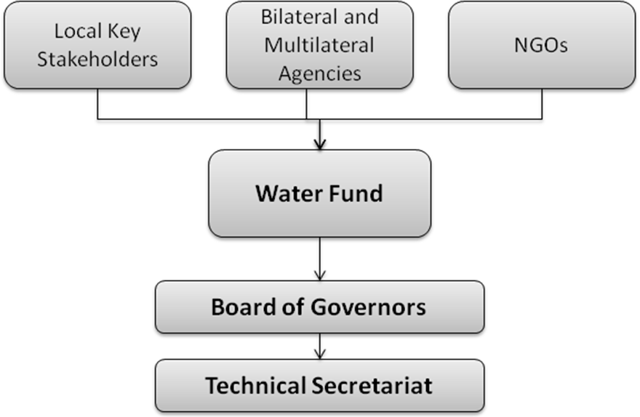
- Key Local Stakeholders:
- The key stakeholders can be classified in the following groups, based on the types of incentives with which they participate:
- Large water users (e.g., private sector, water utility companies, hydropower, and agriculture): These users will benefit from Water Funds through improved provision of the water resource in the long term, but also through reduced water treatment costs and more consistent flows during the dry seasons in the short term.
- Local populations: Local populations in urban and rural areas benefit by having a high quality resource that comes from a healthy watershed.
- Farmers and private reserves on the watershed: The population in key areas of the watershed for water provision will benefit through incentives and direct payments for ecosystem services or other environmental projects.
- Protected Area Authority: Protected Area Authorities will also benefit from the Water Funds’ activities, namely through the implementation of projects directly related to maintaining and improving hydrological environmental services provision (that are part of their Management Plans for the particular Protected Areas involved).
- Board Governance:
- Oversight for the Water Funds is conducted by a Board of Governors (the Board) and supported by the Technical Secretariat. The Board includes representatives of parties contributing to the Water Fund. Other main stakeholders who may not have contributed financially (e.g. local governments, communities) will also be represented on the Board. Board composition would differ, depending on the range and number of stakeholders. To maintain efficiency and effectiveness, the Board will limit its members to no more than 10-12. The Board for each Water Fund will introduce mechanisms to enable the widest stakeholder representation and to ensure a reasonably sized Board.
- The Board will be responsible for selecting the Technical Secretariat and for reviewing and approving the annual budget for the Water Fund. Decisions are taken by consensus. If a decision is not reached by consensus, it goes to a vote. Board will meet once or twice a year.
- One of the Water Funds’ driving principles is that the governance or decision-making structure is not based on how much financial resources institutions provide. Rather, the objective is to keep a balance between private and public institutions to allow representation from academic institutions, local NGOs, and organized communities. This balanced governance structure is the best way to keep consistent participation and interest from the various sectors and reduce possible dominance by any one group.
- Technical Secretariat:
- The Technical Secretariat is the operational arm of the Water Fund – it is responsible for implementing the decisions of the Board and functions as the Water Fund’s Management Team. During the initial stage of the Water Fund, the Technical Secretariat would consist of a locally-hired Manager for the day-to-day operations of the Water Fund. As the Water Fund becomes more established, the Technical Secretariat would grow accordingly with the workload. The Technical Secretariat must have credibility, including technical expertise in watershed management, experience with policies and regulations and good negotiation skills. The Conservancy and the IDB will work closely with the Technical Secretariat to provide guidance and tools for all aspects of the Water Funds’ activities.
- The Technical Secretariat will also receive advice from a Technical Advisory Committee comprised of financial and technical experts. The Board and the Technical Secretariat will determine the final composition of the Advisory Committee based on local activities and related skill demands (e.g. watershed protection expertise, conservation experience, track record in investment management) and the Board and Secretariat’s respective areas of strengths and weaknesses.
b) Financing Structure
- The sources and uses of financing are summarized in Figure 2:
Figure 2: Sources and Uses of Funds
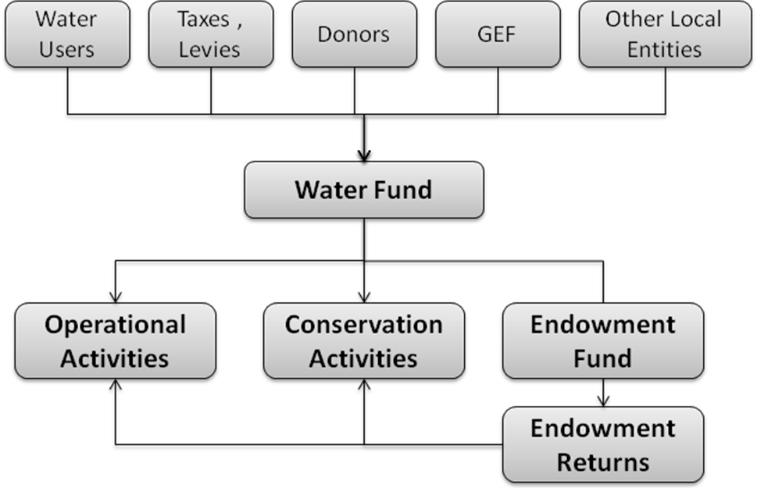

- Source of Finance:
- The Water Funds are designed to be financed from a variety of private and public sources, including:
- Water users (e.g., water utilities, bottling companies): As potentially the largest beneficiaries from the Water Fund activities, the water users are also expected to be the largest financial contributors to the Water Funds.
- Citizens: A fundraising method proposed for the Bogota Water Fund was donations to the Water Fund from citizens through their water bills. Contributions from the general public (low contribution, high volume) can be a significant source of funding, provided the Water Fund launches a strong communication campaign.
- Taxes, levies and public programs: Working with existing local regulations, taxes, fees, or special purpose contributions can be a strong source of finance for Water Funds. In the case of the Quito Water Fund, a municipal ordinance was issued that requires the municipal water company to direct 2% of the water tariffs collections to the Water Fund. In countries like Colombia and Brazil, water laws obligate municipalities and environmental regional authorities to invest resources in the watershed. The Water Funds have managed to capture these entities’ interest because of the opportunity for leverage they can provide and of the participatory frameworks they offer and because water funds can function as implementation arms for public funding Thus, in the right context it will make sense to dedicate resources to studies or lobbying efforts that will help to seize these kinds of opportunities.
- Grants, international cooperation and private foundations: Funding from bilateral, multilateral organizations or independent foundations plays a strategic role in the first two years of the Water Fund’s operations. Often, the grants would be essential in establishing the Water Fund. In the past, the Conservancy has paid, and helped co-finance the initial stages of the Water Funds, including feasibility studies (organizational and technical) and negotiations amongst stakeholders. Grants are also used to fund specific work identified in the conservation plan.
- GEF: Funding will be directed towards critical Water Fund start-up costs. Specifically, funding from GEF will mostly go to endowment funds to secure and co-finance long-term payments for environmental services. It will also co-finance the outreach and feasibility studies as elaborated in Section III.
- Financial returns generated from the Endowment Fund. (see section on Fund Management below)
- The makeup of revenue sources varies from one Water Fund to the next depending on aspects such as the country’s legal framework for water policy, private sector opportunities, type of environmental service provision, and governance strategy. Based on current experiences, Water Funds would expect that the majority of the funding in a 10-year lifespan of the Water Fund to come from the public sector (regional or local environmental authorities, municipalities), and 48% from water users (water utilities, hydropower companies and private citizens). Funding through grants, international cooperation or private foundations, while small in proportion, would be essential in ensuring that the Water Funds are established on a solid foundation.
- An outreach plan will enable Water Fund’s management to start conversations with Water Utilities and will also include an action plan to engage local environmental and municipal authorities. Water Funds will also have to produce a fundraising plan aimed at identifying major contributors including bilateral/multilateral aid agencies, large international foundations, green investors and others parties.
- Fund Management:
- The contributions into the Water Fund will be used for operational expenditures. The net balance of the contributions is allocated in an endowment fund and would be invested by an independent asset manager. Each Water Fund will determine its investment strategy based on the circumstances in country and the expected financial needs. It is envisioned that the asset manager would propose and implement the investment strategy which is approved by the Board and the Technical Secretariat.
- In the case of the Quito Water Fund, average historical returns on its endowment have been between 5 to 6% annually. In 2008, the returns allowed disbursements of nearly US$800,000 in conservation projects, complimented by nearly US$3 million through other contributors. The Quito Water Fund is a good example of financial sustainability and has been further refined for future Water Funds.
c) Operational Structure:
- The operational structure for the Water Funds is designed to prioritize returns based on biodiversity conservation and maximization of payment for environmental services. The key process flow is depicted in Figure 3 and potential conservation activities are presented in Table 1. The details for each of the steps will be elaborated in Section III.
Figure 3: Water Fund Procedures
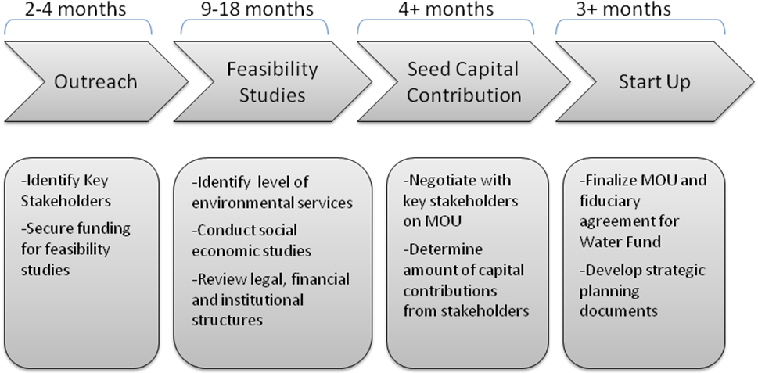

TABLE 1: Conservation activities of Water Funds
Activities | Description | Type of strategy | Relation with water and biodiversity
 |  |  | Area Maintenance (Conservation) | Best practices | Restorations
1. Public protected area management plan implementation
1.1. Co-finance park guards | Improve control of high-risk conservation areas | Threat abatement
1.2. Community-based eco-tourism programs | Reduce threats to buffer zones through income substitution | Threat abatement
1.3. Improve infrastructure management | Support best practices on management of current and new infrastructure in the park | Threat abatement
2. Best practices at the farm or productive unit
2.1. Set aside conservation areas | Environmental payment for areas set aside for conservation on farmland: along streams, headwaters or forest connectivity | Conservation
2.2. Set aside areas and restoration | Restoration payments and future environmental payments for areas set aside for conservation and restoration | Conservation
2.3. Silvopastoral systems | Improve productivity of farm with more environmentally-friendly cattle ranching practices such as live fences, forage plants, rotation of pastures | Best practices
2.4. Agroforestry systems | Introduce environmental practices in the farm | Best practices
2.5. Tourism facilities | Income substitute for land use practices | Conservation

III. Key Steps:
- The following steps describe a typical timeline for the design and consolidation of a Water Fund. Based on the Conservancy’s experience, it takes approximately two years in order to have a Water Fund legally and financially operational.
- Outreach:
- The Water Fund first determines the eligibility criteria and selection of sites (e.g., areas of important biodiversity, populations that will most benefit from watershed conservation (e.g. more than 200,000 people), opportunities for public-private partnerships to address environmental service issues, defined property land titles and engagement of local authorities). This is further elaborated under Section IV,
- Key stakeholders are then identified.
- The first party to be approached is typically the water utility. The Conservancy will work with the water utility to gauge the scope of the business opportunity based on: sediment problems in the watershed – costs, future climate change effects and mitigation opportunities, drastic changes on water natural flows affecting dramatically by dry seasons or contamination problems due to industries or agricultural sector in the upper stream.
- Several workshops would be carried out with technical and managing directors of the water utility. This would help them to understand the methodologies and benefits of developing an environmental watershed management approach and a Water Fund.
- The process also includes identification of other stakeholders to allow them to present their watershed work and convey their visions for watershed protection.
- After working with the stakeholders, the Conservancy elaborates a general vision and project proposal. The Conservancy strives to ensure that the scope of work and objectives for the Water Fund includes inputs from stakeholders.
- A Contract is then signed with the water utility (and/or other stakeholders if necessary such as municipalities and Protected Areas Authorities) to develop biological, hydrological, socio-economic, institutional, and legal feasibility studies.
- The Conservancy estimates that 2 to 4 months are needed to implement this phase with an average cost of US$20,000 (See Annex B for a description of the Bogota Water Fund process and approach and Annex C for financial cost of the Bogota Water Fund. The project expects that these costs will be covered preferably by the water utility, other local stakeholders and bilateral institutions, and secondly by the Conservancy or GEF.
- Feasibility Studies:
- Environmental services and climate change models: The Conservancy, in partnership with national or local research institutions, will run hydrological models such as InVEST, SWAT and FIESTA to identify the most important environmental services provided by nature to humans in and from the watersheds. Key areas such as sediment retention, water yield, or water flow control are identified. These and other models will allow the Conservancy to develop sensitivity scenarios that show responses on environmental services provision according to land use patterns and climate variations over time. These results are essential when drafting the Water Funds’ environmental services goals and figuring out related financial costs to achieve these goals. This becomes a powerful innovative tool to water managers and decision makers.
- Water Funds are placed in areas that are part of a country’s priority areas for conservation. The Conservancy and local stakeholders will apply the Conservation Area Planning (CAP) methodology to determine conservation objectives (e.g. ecosystems or species) in the watershed, set up conservation goals, plot threats, develop strategies, and define a monitoring system. It also runs models that help to identify most cost efficient connectivity areas among important conservation objectives such as forests, alpine grasslands or other habitats. This process results in a map that shows those areas in the watershed that are most important to maintain and those that need to be restored in order to improve connectivity.
- Socio-economic studies: The Conservancy and local partners can run socio-economic models and/or develop simple studies to identify how much it will cost to meet the environmental services goal. There are two types of beneficiaries, i.e. public protected areas and private landowners or reserves.
- As far as protected areas are concerned, financial needs are identified based on local management and financial plans. The studies identify areas of intervention for the Water Fund through improving the hydrological environmental services (e.g. grazing areas for cattle-ranching) and proposing co-financing activities. Those include a higher number of park-guards to enhance enforcement or community eco-tourism projects that offer economic alternative opportunities to activities that constitute threats. It ensures that proposals do not become disincentives for conservation or encounter leakage problems.
- As for private landowners or reserves, it is important to estimate the present and future opportunity cost of conservation in areas allotted for that purpose and/or of the implementation of best practices versus the implications of traditional farming uses. The difference between the two becomes the environmental service payment the Water Fund could provide. Centro Internacional de Agricultura Tropical (CIAT) has developed models, such as ECOSAUT, which quantify the productive function of farmers in the watershed and their willingness to adopt best practices or set aside areas for water conservation and payments (it is possible at that stage to measure their degree of motivation for change and plot it on an “indifference curve”). These models were used in the Bogota Water Fund studies.
- The results of these innovative tools, developed by the Conservancy and partners, are then shared with farmers and others to ensure they have the sufficient information to make decisions. A control testing group will be set up to monitor payments and quantify the contributions of the Water Fund in the future.
- Institutional, financial and legal studies: Review of land titles is extremely important at this stage of the process in order to ensure that the Water Fund will be able to effectively operate and make the appropriate payments or compensations and in return secure conservation agreements.
- It is the critical juncture to identify the most reliable sources of revenue for the Water Fund in the short, medium and long run. The additional studies will be useful to dialogue with a broader pool of potential donors / investors. While it is likely that the local water utility will be the main contributor to the Water Fund, past experiences show that other contributors will be brought in to contribute towards the Water Fund during various stages of development.
- Likewise, a review of the legal conditions that the Water Fund will need to meet will be carried out at this time. Institutional studies will also be key since they will recommend the structure and institution (if applicable) best suited to administer and host the Water Fund as well as its governance arrangements. Decisions on structure and governance will be made by the respective Boards with a view to achieving the highest level of transparency, efficiency, and economic sustainability.
- The Conservancy estimates that 9 to 18 months are needed to implement this Feasibility Studies phase with an average cost of US$350,000. This should be paid by all stakeholders.
- Negotiations and Seed Capital:
- Once the studies are completed, reviewed and discussed among the main stakeholders, a set of general agreements will be reached on issues such as the definition of environmental services and conservation goals, the size of the Water Fund, investment strategy, types of conservation projects, and structure of the Water Fund and governance, among others. These agreements form the Water Fund’s Memorandum of Understanding that encompasses the Trust Fund’s legal documents.
- It is very important to secure the seed capital needed for the first two years of the Water Fund (in addition to funding for the Technical Secretariat and funding for early conservation projects). An estimated amount between US$400,000 to US$1,000,000 for a smaller vs. larger Water Fund allows for two years of financial resources that are used to attract additional investors. Seed money is usually invested as “risk capital” by the water utility, the Conservancy, international cooperation agencies, and Regional Environmental Authorities.
- The Conservancy estimates that it takes at least 4 months to complete this negotiation phase. It can take much longer depending on external political and institutional issues. Technical support from the Conservancy for this phase will be paid for by the Conservancy and the GEF. Contractual resources will mainly be covered by the IDB and part of the seed capital is expected to be brought by the GEF, Water Utility Companies, and other local stakeholders.
- Start Up:
- This phase includes finalizing the Memorandum of Understanding among the partners that is tied to the fiduciary agreements and will ultimately lead to the establishment of the Water Fund. The Terms of Reference and Contract of the Secretariat are finalized during this phase as well.
- The Technical Secretariat is now created and becomes operational. Its staff is hired. It will develop clear and transparent operational procedures to select projects for funding, such as disbursement criteria, eligible project proponents, and monitoring. These procedures are subject to approval of the Water Fund’s Board. As in past experiences, the Conservancy will play an important role in providing technical advice to develop these procedures. IDB´s experience will also be very valuable.
- For a Water Fund to be operational, it needs three strategic planning documents:
- Conservation Plan: The conservation plan is the document that describes where and how the funds are going to be engaged in conservation activities. All projects to be funded should be identified in the conservation plan which delineates clear conservation objectives, geographic areas of intervention, and strategies to achieve the objectives. For the development of the conservation plan, the Conservancy uses a variety of tools and methodologies that ensure access to the best science available.
- Results from the hydrological models (such as InVEST, SWAT and/or FIESTA mentioned above) are analyzed to identify priority areas for investment while climate change model results help predict effects and responses of nature and develop adaptation scenarios.
- The Conservation Area Planning (CAP) methodology also plays a key role for planning, implementing, and measuring conservation success for the Water Fund. The CAP process guides the Water Fund to identify effective conservation strategies. It provides an objective, consistent and transparent accounting of conservation actions and of the intended and actual outcomes of conservation projects. It enables project staff to adapt their actions to changing conditions in order to improve strategy effectiveness and achieve greater conservation impact. This conservation plan differentiates between short-term and medium- and long-term projects. Water Funds will support conservation strategies in the long term (e.g. over 80 years) and pay for activities to be sustained in the long run (e.g. park guards, specific projects linked to maintain or restore environmental services and monitoring) but will also finance activities to be completed in the short term (1-2 years). These may include technical studies, specific communication campaigns, or support to local communities in developing ecotourism projects.
- Financial Plan: The financial plan establishes how much money the Water Fund needs in order to accomplish its conservation objectives according to the conservation plan. It should include financial projections of fund resources, calculate the endowment’s rates of return, recommendations on endowment investment strategy, and lay out a budget for the conservation activities that will be carried out. It also includes a fundraising goal and plan.
- Operations Manual: The operations manual sets very clear and transparent operational procedures on how the Water Fund is to be managed and clear rules on how projects will be chosen for funding. The operations manual lays out how the funding is going to be provided to those areas and activities identified in the conservation plan. Some important information that the operations manual will provide includes:
  - Decision-making processes within the Water Fund
  - Protocol for project and program selection for funding by the Water Fund
  - Policy and process for administrating conservation agreements with environmental services providers and deal with non-compliance actions.
  - Role of the Water Fund’s Technical Advisory Committee
  - Description of organizations/individuals that are eligible to receive funding
  - Protocol to avoid conflicts of interest in the management of the Water Fund
  - Protocol for equipment and supplies acquisition
  - Petty cash protocol.
- The Conservancy estimates that at least 3 months are needed to accomplish this phase. Technical support from the Conservancy for this phase will be paid for by the Conservancy and GEF. Contractual resources will be covered mainly by the water utility, the IDB and part of the seed capital is expected to come from the GEF.
- Growth and Consolidation:
- The next phase revolves around the actual management and growth of the Water Fund, e.g. fundraising activities, support of watershed projects, and monitoring and communication of the results to water users, stakeholders and the public in general.
- The Conservancy considers a Water Fund consolidated when there is a diversified and sustainable stream of financial resources flowing both into the endowment and conservation projects. The amount of time and financial resources needed to reach this stage depends on many variables such as financial and investment projections, efficiency and effectiveness of the Water Fund in implementing its objectives, among others. Annex C shows the projections for the Bogota Water Fund currently in the initial stages of the growth phase.
IV. Key Selection Criteria
a) Legal Framework:
- The legal framework should exist in country that would permit the creation of Water Funds as autonomous foundations or trust funds. In case the appropriate legal framework does not exist, Water Funds can still be established by a) passing a special law only to establish that Water Fund and grant it tax benefits, setting up an offshore Fund in a country with flexible and reliable legal system (e.g. Netherlands, United Kingdom, United States), c) or establishing the Water Fund through a bilateral or other international agreement, rather under national legislation.
- Tax exemption of earnings on endowment investments should exist, both at the source (i.e. where the money is invested) or in the destination country (where the Water Fund is legally registered).
- Conflict of interest rules have to be clearly defined (i.e. in their by-laws and operations manuals) to prevent Board members or staff, and their family members, from receiving any grants or any kind of economic benefits from the Water Fund.
- Conservation agreements will follow clear social and legal standards and would be signed between the Water Funds and farmers / landowners with the help of their local executing partners. Conservation agreements include easements, “servidumbres ecológicas”, and other legal binding documents that ensure conservation in the long run. In order to ensure fair compensation, an opportunity cost analysis of the farmers will be followed. This will reduce any possible political and social risks for the Water Fund in the future.
b) Fund management selection process and general fiduciary responsibilities:
- Best practices indicate that the endowment will be best managed by a third party specialized in asset management that will use its investment expertise while following the Board of Governors’ investment priorities and objectives.
- A call for proposals will help each Water Fund’s Board to shortlist asset managers. They will be evaluated based on their expertise, track records and their terms and conditions. A due diligence process will be conducted in order to identify the best asset manager to be selected by the Board with input from the Technical Secretariat.
- The Board will review the asset manager’s performance regularly. The Water Fund may choose to sign a two- or three-year contract with their respective asset managers and organize a subsequent call for proposals upon termination of the previous contract.
- The Conservancy is currently searching for a reputable international asset management firm to support the oversight of the portfolio investment strategy of the Water Funds on a pro-bono basis. This firm will provide additional guidance to the Water Fund´s Board but will not intervene in the day-to-day activities of the asset manager contracted by the Board. The IDB will be responsible to conduct the final evaluation and selection of the asset management firm.

c) Programming:
- The following two basic criteria will be used to select areas in the watershed in which the Water Fund will have projects implemented from the Water Fund’s endowments and other financial income.
- Environmental provision: Hydrological and environmental services result maps show which areas of the watershed will provide the highest “return on investment”, i.e. in which area one dollar spent in watershed protection will bring about the highest environmental benefit (i.e. abundant and quality water or sediment retention in the Bogota case). These areas are prioritized.
- Biodiversity conservation: Biodiversity conservation corridors and zones will be designed in order to enhance both the freshwater and terrestrial biodiversity and also the provision of environmental services. Contributors to the Water Funds such as the Conservancy and GEF have a significant interest to maximize biodiversity conservation and to demonstrate the conservation benefits of this payment for environmental service approach.
- This methodology will enable the Water Fund’s Technical Secretariat to map out the entire watershed with priority areas for preferred action ranked by importance. Using this set of priority areas as a starting point, other criteria, such as socio-economic, institutional, or contextual (e.g. opportunities for public-private partnerships, defined property land titles and engagement of local authorities), can be considered and integrated into the prioritization process. Other environmental maps and criteria can be included such as carbon sequestration. These additional criteria may change the urgency or order of interventions or result in the inclusion of an adjacent marginal area. But they will likely not change the shortlist of important areas where the Water Fund will concentrate its actions.
V. Key Outcomes, Impacts, & Indicators:
a) Financial Sustainability:
- Water Funds are designed as a long-term financial mechanism, so sustainability is embedded in the design of the Water Funds. They were created to last at least for 80 years. Unlike other watershed projects, which typically last for 5 years at the most because project financing runs out, this institutional arrangement allows for funding to be available in the long run. This is extremely important when signing long-term conservation agreements with landowners based in the watershed, guaranteeing to water users hydrologic adjustments to land use changes, or planning conservation projects which usually take several years and sometimes decades to show significant results.
- As described earlier, financial sustainability can be achieved in the following manner:
- If conservation projects and related spending are well managed, they would not exceed whatever financial income will be produced that year, thus never “touching” the actual capital of the Water Funds (unless donors earmark their contributions for a sinking fund that has a limited lifespan).
- There may be questions however about how valuable for watershed protection it is to have a Fund’s capital tied up for eternity instead of being used. In the US, foundations have to spend 5% of their endowment every year. Water Funds’ Boards will have to decide how to balance financial sustainability with the ability to intervene immediately and fund more conservation projects.
- Another way to ensure that Water Funds will be financially sustainable is if they manage to continue to raise money over time. As Funds start to show successes on the ground, more donors might be drawn to contribute, at a small scale (local communities or possibly individuals around the world interested in those Water Funds) or a larger one (e.g. new foundations, high net worth individuals from country or from overseas, green investors).
- Financial sustainability is one of the metrics that Water Funds will use to measure their success. The Platform will strive to have at least four of its Water Funds meet their endowment income and conservation project financial goals.
- Another way that Water Funds ensure long-term sustainability – not limited to the financial aspect – is by working closely and coordinating with local authorities. For example, in the case of the Quito Water Fund, The Conservancy first approached the Mayor of the city with the idea of the Water Fund. The Mayor was a key element in involving the water company and getting the fund created. The Conservancy kept working with the Municipality over an 8-year period to get an ordinance that would ensure permanent flow of funding from the water company to the Quito Water Fund. In the creation of the new Water Funds, this same type of coordination and relationship is expected. The local governments would be essential for establishing local regulations, ordinances or taxes that can help the fund to become sustainable in the long term.
- Overall, Water Funds reduce the need for donor support for biodiversity protection by putting into place accountable and verifiable funding mechanisms for conservation.
b) Environmental Mitigation and Impact:
- The Platform has clear objectives with respect to environmental service provision and conservation:
- Effective conservation of more than 800,000 hectares in public natural areas directly linked to hydrological environmental services provision ensured.
- At least 20,000 hectares set aside for conservation and more than 50,000 hectares on farmlands in the watersheds managed according to best practices (along with conservation agreements in place).
- Environmental services provision meets the improvement target goal in at least 4 Water Funds.
- Working closely with the private sector and local authorities will bring about another important benefit. Indeed, a major obstacle in properly evaluating water availability, reliance and response by the private sector and local authorities hinges on poorly coordinated methods for estimating water use and impacts at operational and site levels, and in the miscalculation of embedded water in supply chains. This information in the hands of the private sector and local authorities will begin to drive down risk, quantify stewardship approaches, identify best practices, define meaningful water strategies, and provide information and data to support better water policies and regulations.
c) Other Outcomes – Social / Institutional:
- Water Fund benefits will not be limited to financial and environmental ones. They will also be of a social and institutional nature.
Social:
- More than 12 million people have improved long-term supplies of water in Latin America.
- At least 1,200 farmers have increased their annual incomes after the third year.
- Awareness of local communities based in watershed areas has been raised and donations have been collected among the population to cover approximately 20% of the fund raising target thanks to the implementation of at least two communication campaigns about the Water Funds in each site.
- Improved public confidence in private sector and water utilities – People are becoming more aware of harmful environmental practices, with the backlash against bottling water companies being a very recent example. The challenge for the general public is to be able to understand and verify what private sector companies are actually doing when it comes to sustainability. Water Funds are transparent and accountable mechanisms through which stakeholders can be engaged and determine what are the conservation results from investments and so build increased trust and confidence in the private sector and water utilities that they are doing the right thing.
Institutional:
- Equal or balanced participation of private and public stakeholders in governance of all the Water Funds supported by the Platform.
- Conservation agreements signed with more than 1,200 farmers.
- Publication of Water Funds’ achievements (financial results, conservation outcomes) at the mid-term point and at the end of the project.
- Long-term Water Fund Platform designed in partnership between the IDB and The Conservancy.
- Capacity to effectively partner with the private sector built: the private sector often encounters challenges in building long-term working partnerships with governments, NGOs, communities, academic centers and others as projects tend to create short-term vehicles for cooperation. This Platform will help build long lasting structures (e.g., Water Funds) through which the private sector can support freshwater conservation and monitor their investments.
d) Lessons Learned:
- The Quito Water Fund has demonstrated both great achievements and valuable lessons learned. FONAG has achieved a strong and consistent growth in capital, from less than US$2.7 million in 2005 to US$5.4million in 2008, and is projected to reach US$8.5million by the end of 2010. Financial leveraging has been high, whereby only 15% of total project costs has been financed through endowment income, while the rest was raised from various partners (including investors and other donors). A total of 20 projects are either completed or funded by FONAG with the following areas of focus:
- Extending vegetation cover
- Communication
- Environmental education
- Capacity building – around watershed management
- Water management program
- The review of FONAG’s operations and history has helped develop lessons learned that were then taken into account in the design of subsequent Funds. These include:
- It is key to maintain a long-term view of the watershed
- Fundraising should include main stakeholders and involve both public and private sectors. International NGOs provide transparency and thus increase level of confidence of multilaterals and international / national donors.
- FONAG is a separate independent institution in which stakeholders feel represented. It positions itself as the Water Fund for all, which brings trust and credibility.
- FONAG constantly communicates to its different stakeholders up in the watershed and in the city.
- The investment (in terms of time and money) in the start-up process time and resources is minimal but essential.
- Implementation of activities should start immediately to demonstrate results. Positive results will build credibility and bring in more resources.
- Clear conservation and environmental services goals should be developed for the Water Fund. This is vital to develop a payment for environmental services scheme based on an accountability format.
- A robust but simple accountability system to report progress on biological, environmental services and socioeconomic goals should be designed and implemented.
e) Monitoring and Performance Indicators:
i) Monitoring:
- The monitoring system will be defined in more detail in the Operations Manual, as agreed upon with the IDB and will include establishment of:
- Baselines and changes over time in indicator values of the status of focal biodiversity and socioeconomic attributes that the project is intending to impact, and
- Indicators of implementation steps necessary to bring about those benefits.
- Control groups will be set up on the watersheds to compare benefits with project and without project.
- Monitoring will track progress towards objectives set for implementation and levels of impacts to be achieved for individual Funds and for the Platform as a whole. As the Platform will be implemented over a period of five years, the data gathered through monitoring will be used regularly to evaluate the progress being made in implementing strategies, the impacts that those strategies are having on biodiversity and society, and to adapt and improve upon them to achieve project targets.
- Annual reports will be developed for a broad range of stakeholders and the public as a whole. The Water Funds will also design web sites and send regular reports from the field to key stakeholders and national and international partners.
- Internally, the Technical Secretariat will develop financial and technical reports every quarter for the Board. Financial reports are prepared every month. Water Funds’ Boards may choose to disclose financial reports to the public. Depending on the country, release of financial information to the public may be compulsory.
- The Platform will also support evaluation of how to overcome limitations to payment for environmental services schemes identified in the STAP Guideline document, namely: (i) non-compliance; (ii) poor administrative selection; (iii) spatial demand spillovers; and (iv) adverse self-selection.
ii) Indicators:
- Annual performance indicators will be developed to track the Water Funds’ progress towards its financial, environmental, social, economic, and institutional goals.
Financial:
Financial reports should include the following performance indicators as minimum:
- Total $ raised to date vs. projections (in the period and since inception),
- Breakdown of funds raised per investment vehicle (e.g. endowment / sinking funds),
- Total amounts disbursed in conservation projects vs. projections and as a % of capital raised (in the period and since inception),
- Overall operating / administrative costs and itemization by expense category vs. projections and as a % of operating income and a % of amounts disbursed in conservation projects,
- Investment performances of various investment vehicles (e.g. trust funds) vs. projections and vs. corresponding asset category benchmarks
Environmental:
- Environmental services: These results will start to show levels of significance after the third to fifth year of conservation project implementation. Monitoring systems will be put in place and proper equipment will be acquired to develop this essential element of the Platform. Indicators of impact will include:
- % of standard deviation from historical means of water flows on dry season.
- Tons of sediments retained (comparisons between years and projections from models)
- Changes in nutrient and bacterial concentrations in water over time
- Incorporation of best management practices in dam operation (e.g., number of dams that have implemented environmental flows recommendations in their management, number of water withdrawal permits that incorporate environmental flow provisions),
- Changes in water regulations (e.g., number of improvements in water regulations or new regulations),
- Amount of carbon sequestered.
- Biodiversity: Birds, mammals and fishes and all levels of biodiversity in the ecosystems affected by the various Water Funds will improve due to better ecosystem health, more sustainable agricultural practices, and restoration and improved stewardship of forested areas. The project has initially estimated positive environmental benefits on a certain amount of hectares which will be restored and/or protected. The Water Funds will provide a modeling tool and best practices to help with ecosystem-based adaptation to climate change. The Conservancy has piloted these tools in other areas. Indicators of impact will include:
- # of Hectares (Ha) restored or protected with conservation agreements and easements for 25 years and/or indefinitely, at least 25,000 Ha.
- # of kilometers of basin habitat that will benefit from the Water Funds
- Changes in extent of natural vegetation over time
- Improvement of richness of species in places where monitoring will take place
- Improve connectivity and reduce fragmentation index
- Improve habitat and viability for endangered species to be identified in monitoring protocol
- Improved management of protected areas (e.g., increased funding, increased number of park guards, improvement of management plan),
Social:
- The direct project beneficiaries are both the service users, namely the inhabitants of the municipalities or cities which get the water from these rivers, as well as farmers and agro businesses that use water for irrigation and industrial settlements located in the area and those farmers that provide the hydrological environmental services in the upper part of the watersheds. Local landowners who will be compensated for agreeing to set their land aside for conservation will also benefit financially from environmental payments. The projects funded or implemented by the Water Fund will contribute to social strengthening as long as actual involvement of local communities in the decision-making process is guaranteed. Improving the living conditions of rural populations settled in the watersheds and building their capacity constitutes another project goal. Indicators of impact will include:
- # of families receiving direct or indirect payments in the watershed areas.
- $ per family per year (or equivalent in project costs) coming from the payment for environmental services.
- Improvement in local capacity
Economic:
- Depending on the type of environmental service setting, economic impacts will vary too. Water facilities will reduce treatment costs due to better quality of water naturally flowing from the watershed. Large water users such as agricultural associations will avoid future investments to obtain water from other places. Cities will obtain better water quality and hopefully sufficient quantity allowing them to also steer clear of future outlays to secure water for their population. Indicators of impact will include:
- Cost savings / year on treatment cost of water utility companies
- Additional earnings / ha by farmers and agricultural associations / cooperatives and by utility company on water sold due to improvement in water quality.
- Other associated risks due to water scarcity or sediments to be identified by the monitoring component of the project.
Institutional:
- Water Funds are structured to ensure an innovative integrated resource management vision, in which public-private partnerships are designed in a participatory way to ensure stakeholder-led decision-making. Indicators of impact will include:
- Balanced participation and decision-making by different stakeholders in the governance of the Water Fund mechanism.
- Total number of stakeholders (individuals and institutions) involved in the fund (public and private)
- An accountability system (quarterly reviews to Board of Governors and annual written reports to public) will show indicators on environmental, social and economic performance.
- Hold annual public reporting audiences targeted at water users and also the general public.
- Information about the project results delivered to inhabitants who benefit from the project through a partnership with local newspapers and radio stations. Number of publications or radio news bulletins and a biannual opinion survey.
VI. GEF Additionality:
- This Platform is designed to ensure the effectiveness of the IDB as a GEF executing agency and the Conservancy as the project executing agency to advance freshwater protection across LAC.
- The GEF funds will be applied for scaling up and replicating the Water Funds in the region to achieve additional global environmental benefits. GEF funding will help move the Water Fund development beyond a site-by-site basis to provide biodiversity conservation at the scales needed in response to on-going watershed degradation and loss of freshwater species and ecosystems.
- The Platform will advance the Council’s mandate to enhance the level of engagement of the GEF with the private sector as a means to generate global environmental benefits in a sustainable and cost effective manner. GEF’s funding of the proposed Platform will leverage significant contributions from multiple sources including governments, bilateral aid agencies, foundations, and most notably the private sector across LAC. The Platform is designed to change behaviour in the private sector which is essential in achieving GEF objectives. The establishment of this Platform for private-sector entities participation will influence investment decision-making towards technology and infrastructure investments that yield global environmental benefits. The GEF funded activities will be additional in the sense that they will respond directly and specifically to the operational programs of GEF and fill possible operational gaps in understanding and approaches identified by the Scientific and Technical Advisory Panel (STAP) under Payment for Environmental Services (Guideline Document GEF/C.35/ Inf.12, June 2, 2009).
- The GEF funds will be applied to conducting diagnostic analyses, establishing long-term cooperative mechanisms, and supporting associated institutional strengthening that will capture payment for environmental services. Specifically, GEF funding will be directed primarily at designing, negotiating, capitalizing and implementing the new Water Funds in at least five priority watersheds. This process will include community consultations and identification of the threats to biodiversity and ecosystems, indicator development, baseline definition and monitoring of biodiversity and other global benefits derived from the proposed mechanisms, and knowledge management. The Platform will demonstrate methodologies and policy tools that could be replicated on a larger scale by other partners in other regions of the globe.
- GEF is essential for the Platform as it can help facilitate a supportive policy and institutional environment, provide financial support for incremental and transient risk in the establishment of Water Funds, and provide access to worldwide experience and global information networks
- GEF Leveraging:
- GEF’s contribution to the platform will be matched by a ratio of 1:3 from donations coming from the private sector, the Conservancy, and local and regional governments and public companies. Thus, the Platform’s Water Funds component will raise at least 15 million dollars from local, national and international sources in the selected countries.
- These assumptions are based on the following trends and projections from the feasibility studies done for the Water Funds:
- Quito Water Fund has capital of nearly US$ 6 million after 9 years. It has actually doubled its initial projections.
- Bogota Water Fund has seed capital of US$ 650,000.
- East Cauca Valley Water Fund has seed capital of US$ 2.1 million.
- Paute Water Fund has US$ 500,000.
- The Bogota, East Cauca Valley, Paute and Zamora Water Funds are expected to leverage at least US$ 10 million together over the next 5 years (conservative scenario).
- Another potential financial benefit is a sort of multiplier effect that would see an increase in public and private funding directed at watershed protection, i.e. benefiting the various Water Funds but also other watershed protection-related activities in the Water Funds’ region.
- Benefits & Return:
- The Platform will generate a number of tangible benefits and returns, some of which can actually be quantified.
- Water utilities and farmers entering into agreements with the various Water Funds will be the ones to enjoy direct economic returns and benefits in the context of this Platform. Even though it is difficult to estimate a precise amount, it is expected that water utilities will incur cost savings on treatment and dam operations. Based on models developed by the Conservancy and Water Utility companies, most farmers should increase their annual incomes after the third year due to implementation of best agricultural best practices that increase productivity or payment of conservation agreements.
- Another benefit that is at the intersection of conservation and economics is the fact that as a result of the Water Funds’ interventions watershed protection strategy would be more effective than a “business as usual” approach. What this means is that conservation benefits of the projects implemented in watershed areas (possibly expressed in marginal monetary gains from having more abundant and/or quality water) would outweigh operational recurrent costs in filtration or capital cost of new infrastructure development or other sort of investments made by water utilities to improve water sourcing.
VII. Platform Management
- Management Structure
- Figure 4 shows the management structure for the Platform. The Platform will be led, managed and implemented by the Conservancy’s Latin American Regional Office. A project manager would be hired to oversee the management of the Platform. A Joint Management Committee between the Conservancy and the IDB will approve work plans; hold quarterly meetings to review progress and performance on each project supported under the Platform. The Conservancy and the IDB will coordinate internally with its country-based staff to ensure coherent approaches and actions.
- As with the Quito Water Fund, the Conservancy will be on the Board and Technical Advisory Committee of the Water Funds supported by the Platform. The Conservancy will make formal request to stakeholders for approval for this in close collaboration with the IDB.

Figure 4: Platform Management Structure
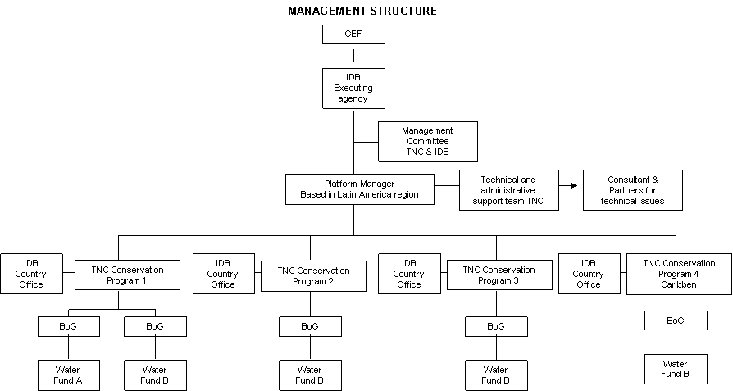
- The program management, selection criteria, implementation plan, safeguard policies, disbursement, procurement, knowledge management system, and financial management will be described in further detail in an Operations Manual to be developed in coordination with the IDB. The Manual will detail the performance indicators, as approved by the IDB. It will also provide guidance on how this Platform implementation will help address those obstacles to effectiveness that the GEF has identified to payment for environmental service approaches, i.e. non-compliance, poor administrative selection, spatial demand spillovers, and adverse self-selection.
- The Operations Manual will be completed after the proposal receives the no-objection from GEF’s Council and in preparation for CEO endorsement. Grant disbursement will be conditioned on the approval of the Operations Manual by the IDB as the GEF Executing Agency.
- Operations Manuals will be developed for each Water Fund that will be expected to help contribute to knowledge management.
- Disbursement and Implementation
- Disbursements by the IDB will be carried out in consultation with the Conservancy. An implementation plan will be developed and included in the Project’s Operations Manual.
- The Conservancy will administer the resources disbursed by the IDB, through agreements defined in the Operations Manual. The Conservancy has the financial mechanisms and standard operating procedures (SOPs) to be able to effectively administer the funds and ensure successful implementation of the Platform activities.
- The Platform will be implemented with the on-going and complete engagement of the private sector. The implementation of the Platform will build on the Conservancy’s experience in testing the interest of the private sector in such mechanisms as financial tools for biodiversity conservation. All areas selected for Water Funds will comply with the criteria delineated in the Operations Manual. New areas will be added from financial resources leveraged through this Platform.
VIII. Knowledge Management
- In consultation with the IDB, the Management Team and all staff involved in implementation of this Platform teams will focus on innovation and sharing of lessons learned throughout this Platform’s implementation. They will be able to draw on the IDB’s existing mechanisms for knowledge management. The Operations Manual will include more details on the Water Fund’s knowledge management system.
IX. Institutional Approach
- The proposed Platform will be implemented by the IDB with the Conservancy as the executing partner. Other agencies involved in implementation of the Water Funds include the Centro Internacional de Agricultura Tropical (CIAT), the Trust Funds created to manage the Water Funds, the water utilities, the national parks agencies, private companies, and others.
X. Fiduciary Oversight Arrangements and Safeguard Procedures and Frameworks
- The fiduciary arrangements and social and environmental safeguard procedures and frameworks will be those of the IDB as the GEF Executing Agency and of the countries in which the project’s Water Funds are located.
XI. Expected Global Environmental Benefits
- The proposed Platform aims to reduce the impact that some private sector companies can have on rapidly disappearing freshwater biodiversity as well as terrestrial and marine biodiversity that relies on freshwater systems. Investments will be directed towards conservation of biodiversity of global importance in the watersheds that provide water for human consumption. The Platform creates voluntary mechanisms that reduce the need for donor funds, directing private sector capital toward freshwater protection with returns on their investments. This is further elaborated in Annex A.
- This Platform supports the GEF objectives on biodiversity by: (i) strengthening and financing protected area systems; (ii) improving management of upstream catchment areas with important freshwater and terrestrial biodiversity; (iii) scaling up watershed service markets for protection of ecosystem services; (iv) quantifying stewardship approaches to provide improved information and data in order to support sustainable water management; (v) building capacity of the private sector and water utilities to work with communities and stakeholders on conservation of freshwater systems.
XII. consistency of the platform with national/regional priorities/plans:
- The Platform is consistent with national policies and strategies for conservation of freshwater ecosystems and watershed management in the potential four countries involved (Mexico, Colombia, Peru and Brazil) and a Caribbean island country to be selected during Platform implementation. The selection of the specific sub-national locations will be done jointly between the Conservancy and the Bank’s Country Offices in coordination with the relevant national water authorities and protected area agencies.
XIII. consistency of the platform with gef strategies and strategic programs:
- The initiative will directly address the GEF Biodiversity Strategy, particularly Strategic Objective No. 1 (SO1), “ To Catalyze Sustainability of Protected Area (PA) Systems” and Strategic Objective No. 2 (S02), " To Mainstream Biodiversity in Productive Landscape/Seascapes and Sectors." Consistent with the Strategic Program #1 “Sustainable Financing of PA Systems at the National Level,” the Platform advances sustainable finance of PAs and PA systems by establishing public-private sector funds for the protection of biodiversity and freshwater ecosystems, developing scientific studies to direct highest return on conservation funding and strengthening financial planning and management capacity. The Platform also promotes Strategic Program No. 3 "Strengthening Terrestrial Protected Area Networks," since it aims to fill representation gaps in terrestrial and particularly freshwater ecosystems in national protected areas systems through the creation of new PAs and the expansion/strengthening of existing ones. Finally, the Platform is also consistent with Biodiversity Strategic Program No. 5 “Fostering Markets for Biodiversity Goods and Services” as it uses a voluntary mechanism to harness local and regional financial resources. Specifically, Water Funds are long-term sources of financing for the conservation of protected and other designated areas that provide water and other ecological services to businesses and communities. Water Funds, consistent with the Earth Fund objectives, leverage funding for environmentally sound and sustainable economic development.
XIV. Outline the Coordination with other related initiatives:
- The Project Management Team and all staff will be responsible for ensuring effective communications with related initiatives. The initiative will coordinate with all strategic alliances and projects active in freshwater protection and conservation finance, from the public and private sectors (national and international), bilateral and multilateral, (e.g. National Water Agencies, Water Fees Regulating Agencies, GEF, UNEP, UNDP, UN Water). The initiative will collaborate with programs and projects of ADERASA, the Inter-American Development Bank’s Water Initiative, the IFC, the Katoomba Group, and the Spanish Water & Sanitation Fund for Latin America. It will also collaborate with the Global Water Partnership (GWP) which is working to advance integrated water resource management. The Conservancy is a new member of the World Water Council (WWC) and will work with WWC and its private sector and UN members. The Conservancy is also working with the new Latin America and the Caribbean Water Center co-founded by the IDB on capacity building of professionals across the hemisphere. The Management Team and Country Teams will determine best opportunities for linkages with existing programs and will ensure complementarity and avoid duplication of efforts.
XV. value-added of GEF involvement in the platform demonstrated through incremental reasoning :
- As noted by the Fourteenth Meeting of the Forum of Ministers of the Environment of Latin America and the Caribbean, one of the challenges in protecting the environment and health of water resources across the hemisphere is to implement integral management systems that will incorporate the ecological expense of maintaining forests, wetlands, lagoon systems and coastal estuaries, in addition to seeking the manner in which to record the environmental services provided by ecosystems through appropriate economic instruments in such a way that the value of maintaining the health of these ecosystems can be appreciated. Overcoming these challenges requires effective engagement of the private sector and local authorities in investing in water resource management and watershed protection, as well as having baseline information upon which to evaluate conservation benefits. Unlike the previous attempts at watershed management, this Platform will bring together the private sector, local authorities, NGOs, communities, academic institutions, and other stakeholders to manage water resources in more coordinated and sustainable manner. The Platform will inform responses to changes in regional patterns of water use given that Water Funds aim at improving water resource management at the watershed level. Without the interventions performed under this Platform, the existing watershed protection mechanisms will be limited in harnessing the potential for slowing or avoiding the loss of freshwater ecosystems at a larger scale. Across LAC, this Platform will help the private sector and water utilities reduce their impacts on watersheds, the general public value environmental services, and build public and private sector confidence in sustainable water management. This intervention will help move integrated water management from an exercise on paper to reality. The GEF’s name-recognition will bolster the attention paid to the role of protected areas in these approaches and mechanisms, thereby averting continued loss of protected area systems as they are converted for agriculture, mining and other uses.

XVI. risks, including climate change risks, that might prevent the project objective(s) from being achieved, and if possible including risk mitigation measures that will be taken:
The moderate to major risks that could affect the project and the associated mitigation measures are as follows:

Risk | Mitigation Measure
Unwillingness of end users to pay for the environmental services upon which they depend | Clear information on the benefits to users by ensuring provision of water resource in long-term, reduced water treatment costs, stable flows during dry season
Failure to achieve social and environmental results by private sector | Ongoing monitoring to determine if initiatives are making progress toward their goals and objectives and adaptive management to make changes as needed
Lack of freshwater data | Use of best available proxies until better numbers obtained; inclusion of additional data gathering as part of implementation and monitoring plans

XVII. expected cost-effectiveness of the project:
- The initiative strengthens the financing of protected area systems and thus the conservation of globally critical biodiversity. Studies carried out by the Conservancy show the economic value of protected areas in providing humans with water. In Venezuela, for example, protected areas protect the source of 530 thousand litres of water a second, serving 83% of the population, saving municipalities and industries hundreds of millions of dollars on avoided siltation and sedimentation, and generating energy worth $12.5 billion a year. In Venezuela, for the 20% of irrigated farms which depend on water originating in National Parks, conservation generates water supplies worth $215 million; maintaining water quality and minimising downstream sedimentation and siltation save farmers’ costs of around $30 million over the schemes’ lifespan. Around 2.7 million people in Peru use water originating from 16 protected areas. These people consume approximately 254.9 million m3 annually, which is equivalent to a value of US$81 million. Conservation adds value in improved water availability, as well as saving considerable costs associated with coping with water shortage, and dealing with sedimentation and siltation. In Bolivia, the water supplied from the Sama Biological Reserve to city dwellers and hydropower is estimated to be worth almost $0.5 million a year, and the potential losses arising from watershed degradation are estimated to total more than $0.25 million.

- Public and private facilities have to spend millions to remove pollutants and sedimentation in order to provide drinking water for residents, water for energy and agricultural production, and water for industries. A study undertaken by the Conservancy and its partners found that water operators in Bogotá, for example, could save an estimated US$4.5 million per year by proactively investing in watershed protection so that natural areas like alpine grasslands and mountain forests provide natural sedimentation filtering services for them. The Bogota Water Fund is expected to generate US$60 million for water and biodiversity protection over 10 years.

XVIII. the comparative advantage of GEF agency:

- The IDB is the leading financial institution at the regional level in all sectors and particularly in water with a strong presence and sector experts in 26 countries in LAC. Since the creation of the Water and Sanitation Division and the approval of the Water Supply and Sanitation Initiative in 2007, the IDB has been ambitiously increasing its involvement in the sector (252% growth from 2005 to 2008) through the recruitment of new staff, the approval of new financial mechanisms, the attraction of additional bilateral donors (i.e., Spanish Cooperation Fund for Water and Sanitation Fund in LAC) and the creation of a multi-donor water trust fund (AquaFund).

- With these new water funding instruments, increased lending portfolio, and water specialists and country offices in every member country of the Region, the IDB has a clear comparative advantage over other development agencies to ensure an effective implementation, consistency of the Platform with the countries’ development plans, involvement of the relevant national and sub-national agencies and mobilization of significant increased funds to the Platform.

part iii: approval/endorsement by gef operational focal point(s) and GEF agency(ies)

A. Record of Endorsement of GEF Operational Focal Point (S) on Behalf of the Government(S): (Please attach the country endorsement letter(s) or regional endorsement letter(s) with this template).

Name | Position | Ministry | Date (Month, day, year)

B. GEF Agency(ies) Certification
This request has been prepared in accordance with GEF policies and procedures and meets the GEF criteria for project identification and preparation.

Agency Coordinator, Agency name | Signature | Date  (Month, day, year) | Project Contact Person | Telephone | Email Address

Project ID number will be assigned by GEFSEC.
Select only those focal areas from which GEF financing is requested.
Reduction is estimated at 1million tons in 5 years for Bogota watershed
Carmen Revenga and Greg Mock, Pilot Analysis of Global Ecosystems: Freshwater Systems and World Resources 1998-1999 (World Resources Institute, Washington DC).
See previous footnote.
Millennium Ecosystem Assessment: Biodiversity Synthesis. 2005 (Ecosystems and Human Well-Being) and WRI et al., World Resources 2000-2001 (World Resources Institute, Washington DC), pp. 104 – 106.
Vörösmarty, C.J., Green, P., Salisbury, J., and Lammers, R.B. 2000. Global water resources: vulnerability form climate change and population growth. Science 289:284-288.
Information provided by Al Appleton, Ex-Commissioner of Environment for the city of New York.
CIAT 2007, supported by EAAB, the Conservancy, Patrimonio Natural, Parques Nacionales.
Fedesarrollo and Universidad de Los Andes, Valoración de los Beneficios Económicos Provistos por el Sistema de Parques Nacionales Naturales: Una Aplicación del Análisis de Transferencia de Beneficios, 2005.
Brown, Marcia. Foundations of Success. Case study of watershed valuation in the Condor Bioreserve, Ecuador. 2004.
The Quito water fund has been steadily growing with contributions from the different water users, the largest contributors coming from the Quito Water Company (EMAAP) and the Quito Electric Company (EEQ). In 2000, total contributions included $1,000 from the Conservancy and $20,000 from EMAAP. By 2006, the breakdown of total contributions was the following (in thousand dollars): 81 the Conservancy, 3194 EMAAP, 270 EEQ, 24 National Brewery, and 20 Swiss Cooperation. In 2009, the Water Fund had kept growing and the composition of its donations was as follows (in thousand dollars): 81 the Conservancy, 6,223 EMAAP, 405 EEQ, 42 National Brewery, 35 Swiss Cooperation, and 14 private bottling company.
Bogota and East Cauca Valley in Colombia, Cuenca and Paute in Ecuador, and Lima in Peru.
There can be arguments not to consider these types of funding mechanisms payments for environmental services, due to its non voluntary scheme. Regardless of this, they have been and could become significant financial resources to Water Funds.
In Quito 90% comes from the water utility and it is expected to increase to reach 96% in the next decade. A better funding balance is necessary to reduce risks of depending on one single source of revenue, despite that the water fund already has more than US$6 million in capital.
The selection of the asset manager will be made jointly by the Conservancy and the IDB based on independent evaluations.
As noted by the STAP under their review dated 16 January 2010, Table 1 presents linkages between conservation activities and a matrix of relations with water and biodiversity, but does not describe what, if anything, in Table 1 generates land use changes (pressure reduction) that would lead to biodiversity and ecosystem service enhancement. Based on the STAP’s recommendation, the Platform will seek ways to use the Water Funds as a way to test experimentally the effectiveness of the elements in Table 1.
One of the main strengths of The Conservancy has been developing conservation planning tools. During the past 15 years, The Conservancy has developed integrated processes for planning, implementing, and measuring conservation success for its conservation projects. This process is called the “Conservation Action Planning (CAP)” process. The CAP process has been tested with a wide range of projects from different parts of the world and is supported by a network of trained CAP professionals that makes up the Efroymson Coaches Network for Conservation Action Planning.
Source: Rapid Review of Conservation Trust Funds – Conservation Finance Alliance – Spergel, Taïeb, 2008
This target is conservative. The Bogota Water Fund has a target of nearly 33% of total revenue in 10 years.
Environmental services and biodiversity are listed separately.
In Colombia, for example, some of the projects financed by GEF (2001-2009) under the biodiversity focus include activities to protect high mountain ecosystems and protected areas enhancement. None of these projects are directly related to the freshwater ecosystem conservation. Complementarity and no duplication are expected with this proposal since Water Funds will contribute to addressing the lack of financial resources of protected areas and freshwater ecosystems will be conserved through the innovative mechanisms for the long term.

